Spring Boot project created with three controllers

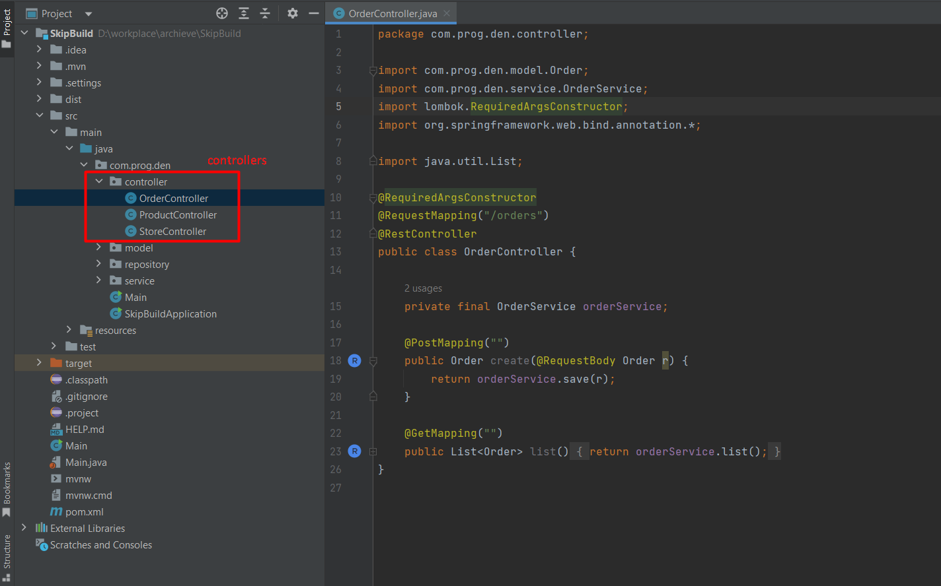

In each of the controller, I have added one GET & one POST request. You can find the postman collections on project root

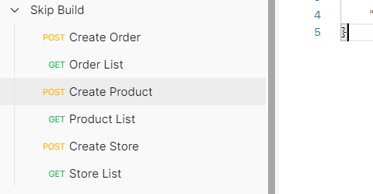

In maven there is a plugin called `maven-jar-plugin` used to build the jar, in this plugin we can mentioned what files to include or exclude while building this jar. So, I have configured this plugin in pom.xml file as shown in picture below

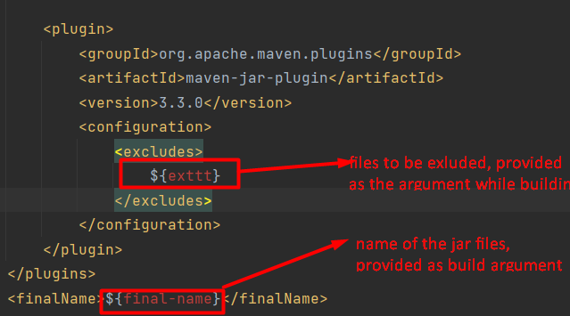

so, in the above configuration there are 2 build arguments required

* **final-name:** name of the target file name
* **exttt:** files for be excluded from the build

Let’s suppose in current project you want to build the jar for *ProductController* with the name of *product-service.jar* and you want those the other 2 controllers *StoreController* & *OrderController* should not be the part of the jar. So, you can run the following maven command to do that.

mvn clean install -Dfinal-name=store-service -Dexttt=**/ProductController.class,**/OrderController.class

The above command will help us to achieve the desired results.

# Building jar for more than multiple controllers

Let’s suppose you have 10 controllers, its means for each of the controller you need to run the earlier specified maven command one by one that is very tedious and time taking task. So, I have written a java class to run maven command on your behalf all you have to do is to add list of controllers in the class and then run the class. This will generate the jar for each controller.

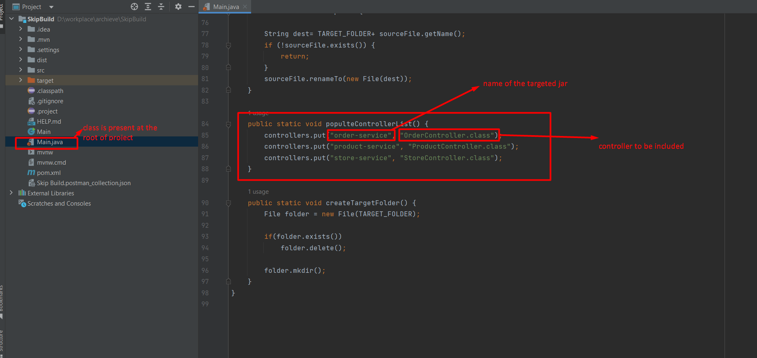

## Steps

1. Add all the controllers name and the required jar name in the code as shown in above picture.
2. Place the java file at the root of project folder
3. Create a folder dist at the project root
4. run the java class you can use (javac Main.java, java Main) to run this class
5. You will find the required jars in folder dist.